**CIVIC EDUCATION**

**CLASS - JSS 1**

**SCHEME OF WORK FOR THIRD TERM**

|  |  |
| --- | --- |
| **WEEK** | **TOPICS** |
| 1 | Revision of last term work |
| 2 | National consciousness and identity |
| 3 | National symbols and their meaning |
| 4 | National symbols (cont.) |
| 5 | National symbols – National Anthem and Pledge |
| 6 and 7 | Measures adopted by Nigeria government to promote unity among Nigerians |
| 8 | How individuals cans promote National Unity |
| 9 | Nigerian constitution |
| 10 – 11 | Revision |
| 12 | Examination |

**WEEK 1 AND 2**

**Topic: National Consciousness and Identity**

**OBJECTIVES** : At the end of the lesson,students should be able to say

Meaning of Consciousness

Meaning of National Consciousness

Meaning of National Identity

Meaning of Consciousness

Consciousness means being able to use one’s sense and mental powers to understand events happening at particular point in time. Consciousness is the state or quality of awareness, or, of being aware of an external object or something within oneself. It has been defined as: sentience, awareness, subjectivity, the ability to experience or to feel, wakefulness, having a sense of selfhood, and the executive control system of the mind.

**National Consciousness**

National Consciousness is the level of a person’s awareness of issues and happenings in the nation and how they affect him/her and others in the nation. It is the love and affection for oneself. This self awareness that translates to self consciousness.

**National Identity**

National Identity is the act of belonging and identifying with a nation. It is represented by the symbols, beliefs, culture and heritages for which the country is known and identified with. These include national symbols like currency, pledge, national anthem, coat of arms, etc. National identity is one’s identity or sense of belonging to one state or to one nation. It is the sense of a nation as a cohesive whole, as represented by distinctive traditions, culture, language and politics.

**WEEK 3 and 4**

**OBJECTIVES** : At the end of the lesson,students should be able to say

Meaning of National Symbol

**The National Symbols**

**The National Flag**: The Nigerian flag which was designed by Mr Taiwo Akinkunmi in 1958 is made up of two colours; white and green. The white part stands for Peace and Unity while the Green represents our rich Agriculture. It is placed in important public places like schools as a sign of patriotism.

**Nigerian Coat of Arms**: This is an emblem of national unity. It has a black Shield representing the good soil of the country, an Eagle which represents strength while the two white Horses represent the dignity and pride of the country. The river Niger and river Benue which flows through parts of the nation are represented by the “Y” symbol marked on the shield. The Flower represents the beauty of the nation. The motto of the country “Unity and Faith” is written in the coat of arms.

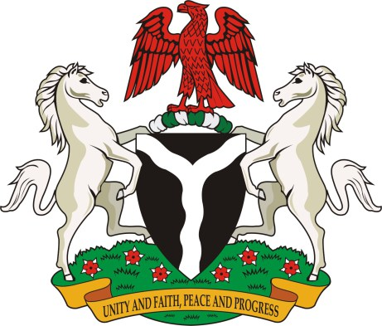

**The Currency**: This is the legal tender (means of transaction) peculiar to the country. This is in units of naira and kobo; with the lowest denomination being five kobo (5k) while the highest is one thousand naira (₦1000). These currencies are universally accepted as means of exchange.

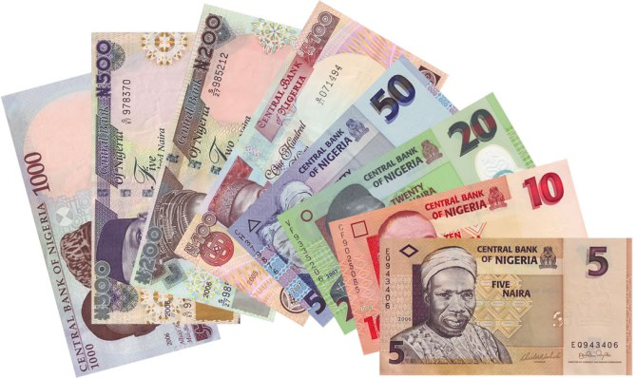

**WEEK 5**

**OBJECTIVES** : At the end of the lesson,students should be able to say

The National Anthem and the National Pledge

The Pledge: It is a solemn promise made by the citizens of Nigeria that they would be loyal to their country. The Nigerian pledge is said thus:

I pledge to Nigeria my country,

To be faithful, loyal and honest,

To serve Nigeria with all my strength,

To defend her unity,

And uphold her honor and glory

So help me God.

The National Anthem: It was adopted in 1978 and replaced the previous anthem, Nigeria, We Hail Thee. The lyrics are a combination of words and phrases taken from five of the best entries in a national contest. The words were put to music by the Nigerian Police Band under the directorship of Benedict E. Odiase.

The National Anthem

Arise, O compatriots, Nigeria’s call obey

To serve our fatherland

With love and strength and faith

The labor of our heroes past

Shall never be in vain

To serve with heart and might

One nation bound in freedom, peace, and unity.

Oh God of creation, direct our noble cause

Guide our leaders right

Help our youth and truth to know

In love and honesty to grow

And living just and true

Great lofty heights attain

To build a nation where peace and justice shall reign.

The Old National Anthem

Nigeria we hail thee

Our own dear native land

Though tribe and tongue may differ

In brotherhood we stand

Nigerians all and proud to serve Our sovereign motherland

Our flag shall be a symbol

That truth and justice reign

In peace or battle honour

And this we count as gain

To pass unto our children

A banner without stain

O God of all creation

Grant this our one request

Help us to build a nation

Where no man is oppressed

And so with peace and plenty

Nigeria may be blessed

The Nigerian passport: This is a document issued by the federal government to citizens who wish to travel to other countries as a means of identity for such individual. Others are:

The constitution

The map of Nigeria

Unity lamp

The national identity card.

**Test and Exercise**

Being able to use one’s sense and mental powers to understand events happening at particular point in time is known as (a) ability (b) knowledge (c) consciousness (d) identity

The Nigeria flag was designed by (a) Flora Shaw (b) Taiwo Akinwunmi (c) Goodluck Jonathan (d) Taiwo Olawunmi

The eagle in the Nigeria coat of arms represent (a) the beauty of the nation (b) the strength of the nation (c) the dignity and pride of the nation (d) the good soil of the land

———– is the level of a person’s awareness of issues and happenings in the nation and how they affect him/her and others in the nation. It is the love and affection for oneself. (a) international consciousness (b) national consciousness (c) personal consciousness (d) general consciousness

The act of belonging and identifying with a nation is (a) national identity (b) national consciousness (c) national symbol (d) none of the above

**WEEK 6 and 7**

**Topic: Promoting National Unity**

**OBJECTIVES** : At the end of the lesson,students should be able to explain

**The means of promoting national unity**

**How individuals can promote national unity**

**Promoting National Unity**

Promoting national unity is the work of everybody in the country, the government and individual should be involved in the means of promoting national unity.

Establishment of institutions (such as unity school): Various institution like unity schools are established for the purpose of promoting unity in the country through accommodating children from any part of the country and giving hem opportunity to learn.

National languages: Despite about the 350 different ethnic groups in Nigeria with different dialects, efforts are being made to promote a national or an official language. For instance English language has been recognized as the official or national language.

Employment and Labor mobility: The federal government employs and transfer workers from different cultural groups to work elsewhere in the country.

Trading activities: The opening of markets in cities and local areas have made people to exchange goods and services together and therefore help to encourage integration.

N.Y.S.C. (National Youth Service Corp) Program Me: This program me is established by the federal government in 1973 to bring about unity among graduates from different institutions, educated fellows to come together from different state to serve their nation for a period of one year.

Transport and communication: Road network, railway lines, telecommunication, bridges and airways are built and constructed by government at various levels to link up rural with urban areas and to ease movement of the people from one place to another, thereby promoting national integration.

**WEEK 8**

**Topic: Promoting National Unity**

**OBJECTIVES** : At the end of the lesson,students should be able to explain

How individuals can promote national unity

**Topic : How Individuals can promote National Unity**

Must be able to tolerate other people

Must be hospitable, show warmth and affection to others.

Avoid discrimination

Allow inter marriage, example of inter marriage is when a Yoruba woman is allowed to marry an Igbo man.

Must develop relationship with others

By showing love and concern for others.

**Test and Exercise**

The N.Y.S.C was established in the year (a) 2005 (b) 1973 (c) 1990 (d) 1995.

Individual can promote national unity by (a) Avoid discrimination (b) disobeying the national laws (c) embezzling public funds (d) fighting with everybody.

The following means are the ways by which the government can promote national unity except (a) N.Y.S.C scheme (b) National language (c) Establishment of institutions (d) Encouraging corruption.

N.Y.S.C means (a) Nationalize Your Skill and Cost (b) National Year of Suffering and Commotion (c) National Youth Service Corps (d) Nigeria Youth Serving Christ.

National unity is possible in Nigeria. true/false.

**WEEK 9**

**Topic: Nigerian Constitution**

**OBJECTIVES** : At the end of the lesson, students should be able to

Define the Constitution

State the Sources of Nigerian Constitution

**What is a Constitution?**

A constitution is the fundamental law, written or unwritten, which establishes the character of a government. A constitution is also a body of fundamental principles or established precedents according to which a state or other organization is acknowledged to be governed.

It is the basic principles which all citizens must abide with. It prescribes the extent and manner of the exercise of a nation’s sovereign power.It is the fundamental and entrenched rules governing the conduct of an organization or nation state, and establishing its concept, character, and structure. It is usually a short document, general in nature and embodying the aspirations and values of its writers and subjects.

**Sources of Nigerian Constitution**

The Nigerian Constitution can be sourced from the following:

Conventions: Conventions are rules of practice that have been accepted because of their long usage.

Common Law: Law based on people’s customs and beliefs, which the courts also recognize is also a source of Nigerian constitution

Historical Documents: Documents containing historical records of people and their traditions

Judicial Precedents: Law emanating from previous court judgements, usually from superior courts. They can also be called case laws.

Act of Legislature: Laws made by the state and national assemblies

Features of Nigerian Constitution

The Nigerian Constitution (1999) has eight different chapters; each of the chapter has sub sections and parts.

The prelude to the chapters states:

We the people of the Federal Republic of Nigeria,

Having firmly and solemnly resolved , to live in unity and harmony as one indivisible and indissoluble sovereign nation under God, dedicated to the promotion of inter-Africa solidarity, world peace, international cooperation and understanding, And to provide for a constitution for the purpose of promoting the good government and welfare of all persons in our country, on the principles of freedom, equality and justice, and for the purpose of consolidating the unity of our people , do hereby make, enact and give to ourselves the following constitution.